α Allocation Tables in seamless, adaptive, group sequential design
This example reflects a registrational Phase II/III seamless trial incorporating
seamless + adaptive (dose/population selection) + group sequential elements.

Trial Assumptions (for context)
- Overall type I error: Two-sided α = 0.05
- Primary endpoint: Progression-Free Survival (PFS)
- Populations:
  - F = Full (ITT) population
  - S = Biomarker-positive subgroup (e.g., PD-L1 high)
- Design:
  - Stage 1: Multi-dose exploration + adaptive decision
  - Stage 2: Confirmatory testing with selected dose (and possibly enriched population)
- Interim analyses:
  - One adaptive interim (no hypothesis testing)
  - Two formal group sequential looks (including final)
- Combination method: Inverse Normal Combination Test

Table 1. Family-wise α Allocation and Gatekeeping Strategy
SAP-style α allocation across hypothesis families
Hypothesis Family | Description | Type | Two-sided α | Gatekeeping / Notes
H1 (Primary) | PFS in S population | Confirmatory | 0.04 | Primary confirmatory path if enrichment is selected
H2 (Supportive / Co-primary) | PFS in F population | Confirmatory | 0.01 | Used if no enrichment, or as supportive evidence
H3 (Key Secondary) | Overall Survival (OS) | Confirmatory (conditional) | 0.00* | *α may be recycled from H1/H2 upon success
SAP Notes (typical language):
- Strong control of the family-wise type I error rate at 0.05 (two-sided) will be maintained.
- A hierarchical gatekeeping strategy will be applied: confirmatory testing of OS is permitted only if the primary PFS hypothesis is rejected.
- The allocation reflects the higher prior plausibility of treatment benefit in the biomarker-positive population.

Table 2. Group Sequential α Spending for Primary Hypothesis H1 (PFS in S)
Two-sided α = 0.04, O’Brien–Fleming–type boundary (Lan–DeMets)
Look | Information Fraction | Timing (Illustrative) | Cumulative α | Incremental α | Notes
1 | 0.50 | ~50% of planned events | 0.0005 | 0.0005 | Very conservative early boundary
2 | 0.75 | ~75% of events | 0.0060 | 0.0055 | Moderate α release
3 | 1.00 | Final analysis | 0.0400 | 0.0340 | Majority of α preserved for final
Interpretation:
- Early stopping for efficacy requires very strong evidence.
- The final analysis boundary is close to the nominal 0.05 test, minimizing loss of power.
(An analogous table would be specified for H2 using α = 0.01, if applicable.)

Table 3. Combination Test Parameters (Inverse Normal Method)
Pre-specified combination of Stage 1 and Stage 2 evidence (H1)
Component | Stage 1 | Stage 2 | Notes
p-value | $$p_{1}$$ | $$p_{2}$$ | Each computed using pre-defined methods
Weight | $$w_{1}=\sqrt{0.40}$$ | $$w_{2}=\sqrt{0.60}$$ | Based on information fractions
Combined statistic | \multicolumn{2}{c}{$Z^{*}=w_{1}Φ^{-1}(1-p_{1})+w_{2}Φ^{-1}(1-p_{2})$} | Single final test
Significance level | \multicolumn{2}{c}{Two-sided α = 0.04 (subject to sequential boundary)}
SAP Clarification:
- Stage 1 data may inform adaptive decisions but contribute to inference only through the pre-specified combination test.
- Type I error is preserved regardless of dose or population selection.

Table 4. Adaptive Decision Rules (Dose and Population Selection)
Illustrative SAP decision framework (executed by the independent DMC)
Decision Step | Data Used (Unblinded) | Pre-specified Rule | Outcome
Dose elimination (safety) | SAE/AESI rates | Eliminate doses exceeding safety threshold | Reduced candidate set
Dose selection (efficacy) | PFS effect estimates | Select dose meeting minimum clinically relevant effect with acceptable safety | Selected dose D*
Population strategy | Subgroup consistency / interaction metrics | If predefined criteria met → enrich S | Enrich S or remain F
Confirmatory path | Selected strategy | Route hypothesis testing through H1 or H2 | Final testing pathway

Example SAP Text (Commonly Used)
“The family-wise two-sided type I error rate will be strongly controlled at 0.05. Interim efficacy analyses will follow a group sequential design using a Lan–DeMets O’Brien–Fleming–type alpha-spending function. Adaptive dose and population selection at the interim analysis will be conducted by the independent DMC. Confirmatory inference will be based on a pre-specified inverse normal combination test to preserve the overall type I error rate.”

Key Takeaway (One Sentence)
In adaptive seamless trials, α is allocated at the family level, spent only at formal group sequential looks, and preserved across adaptive decisions through pre-specified combination testing.

This is basically a healthy design:

Stage 1 (Adaptation): ~35–40% of events

Look #1 (Sequential): ~60% of events

Final: 100% of events

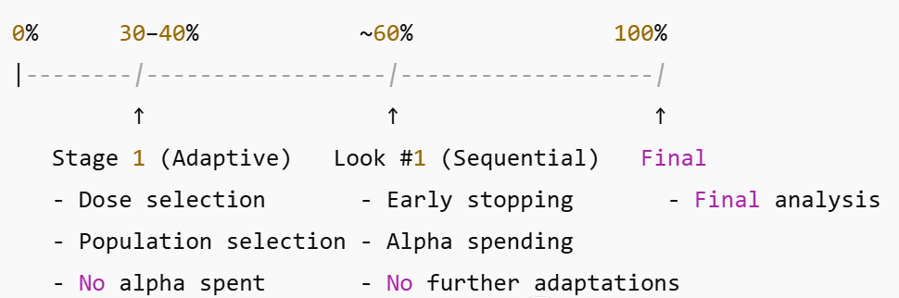

O’Brien–Fleming–Type Alpha-Spending Function

3. Mathematical Form (Lan–DeMets Implementation)
Under the Lan–DeMets framework, an OBF-type alpha-spending function is commonly defined as:
$$α(t)=2\left[1 − Φ\text{ ⁣}\left(\frac{z_{1-α/2}}{\sqrt{t}}\right)\right],0<t≤1$$
where:
- $α(t)$is the cumulative alpha spent at information fraction $t$
- $t$is the information fraction (0–1)
- $Φ(⋅)$is the standard normal cumulative distribution function
- $z_{1-α/2}$is the standard normal quantile corresponding to the nominal two-sided alpha
Key behavior:
- When $t$is small → $α(t)$is extremely small
- When $t→1$→ $α(t)→α$

4. Interpretation at Interim Analyses
At each formal group sequential look:
- The current information fraction $t$is calculated
- The cumulative alpha $α(t)$is obtained from the spending function
- The corresponding critical boundary (Z-value) is determined
Early stopping for efficacy is allowed only if the observed test statistic exceeds this boundary.

5. Typical Boundary Behavior (Illustrative)
For a two-sided α = 0.05 with one interim analysis:
Analysis | Information Fraction | Cumulative α | Approximate Z Boundary
Interim | 0.60 | ~0.005 | ±2.8
Final | 1.00 | 0.05 | ±1.96
Interpretation:
- At the interim look, the required Z-value is very high, making early stopping rare
- At the final analysis, the boundary is essentially identical to a standard 0.05 test

